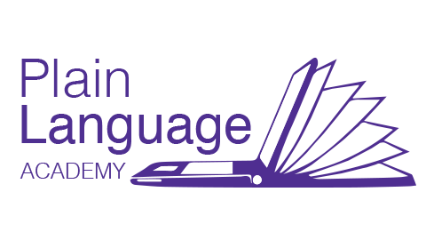
Plain Language Academy Calendar 2023
Log into plainlanguageacademy.moodlecloud.com.
Set up your account. Then choose your courses and register.
Help is at getintouch@plainlanguageacademy.com

Core Courses | Dates | Fee
C1. Plain Language Basics | open | $250 CAD
C2. Audience Awareness | open | $250 CAD
C3. Plain Language Writing and Editing | open | $250 CAD
Register for all three and receive a 15% refund
Advanced Courses  Includes a live session  A1 Creating Clear E-content  with Kate Harrison Whiteside | open | $275 CAD
A2 Editing for Plainer Legal Writing  with Nicole Watkins Campbell, www.watkinscampbell.com | Mar 6 | $275 CAD
A3 Plain Language 2.0 and Health Literacy  with Romina Marazzato Sparano  educlaro.moodlecloud.com in English and Spanish | Feb 27 | $275 USD
A4 Science Supports Plain Language  with Cheryl Stephens, www.cherylstephens.com | Open | $275 CAD
A5 Implementing Plain Language as a Strategic Priority with Sarah Slabbert and Nadja Green,  Plain Language Institute, SA | Apr 3 | $275 CAD
A 6 Focus on Feedback  with Kate Harrison Whiteside | Feb 13 | $275 CAD
A7 Clear Digital Design  With Annie Burger and Liezl van Zyl  Heyplainjane.com | Feb 20 | $275 CAD
A8 Plain Language Project Leadership  with Kate Harrison Whiteside | Apr 16 | $275 CAD
A9 Editing for Plainer Technical Writing  with Nicole Watkins Campbell, www.watkinscampbell.com | Mar 13 | $275 CAD
A11 Putting Clients First in Legal Writing  with Cheryl Stephens, www.cherylstephens.com | Open | $275 CAD
New: Courses in French. Find out more.
Successfully complete any course for a Certificate. Any 6 for a Letter of Achievement.
Add on coaching and consulting services.

