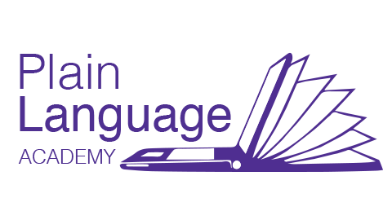
Plain Language Academy Calendar 2018
2018 | Course | Fee
March 1 | 3. Plain Language Writing and Editing | $209
April 1 | 4. Clear Design Practices | $209
 | 1. Plain Language Basics
April 10 | Editing for Plainer Legal Writing | $209
May 1 | 5. Testing and Evaluating | $209
 | 2. Audience Awareness
June 1 | 6. Plain Language Project* | $209
 | 3. Plain Language Writing and Editing | $209
Sept 1 | 4. Clear Design Practices | $209
 | 1. Plain Language Basics | $209
Oct 1 | 5. Testing and Evaluating | $209
 | 2. Audience Awareness | $209
Nov 1 | 6. Plain Language Project* | $209
 | 3. Plain Language Writing and Editing | $209
5 Course Bundle | Courses 1-5 | $899
*Available on demand | Course 6 + Coaching – Code C6_1  Course 6 + Coaching + Consulting – Code C6_2 | $609  $1299
5% GST included | Group rates on request. Pay online. PayPal or Stripe

2018 Calendar

1. Plain Language Basics—Everything you need for a solid understanding of plain language and its process.
January 2, 2018 $209
2. Audience Awareness—Learn to assess audience needs and meet them successfully.
February 1, 2018 $209

3. Plain Language Writing and Editing—Insights on how to effectively plan, write, and edit for clarity.
March 1, 2018 $209
4. Clear Design Practices—Find out how clear layout, information design, and visuals enhance readability.
April 1, 2018 $209
5. Testing and Evaluating—Discover tools and techniques to test for and improve readability and accessibility.
May 1, 2018 $209

6. Plain Language Project —Available in 3-D (different) options.
Course + Coaching + Consulting combinations.
June 1, 2018 $209
Course 6+2= Course+Coaching+Consulting C6_2 $1299
Course 6+1= Course+Coaching C6_1 $609
Five-Course Inclusive Bundle (C1-C5) $899
Advanced: Editing for Plainer Legal Writing – Learn techniques on how to turn legal language into reader-friendly clear language.
January 2, 2018 $209Group rates available. Contact us at getintouch@plainlanguageacademy.com

